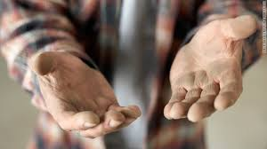

Help the Homeless
Donation(s) Needed:
Twin size sheets sets
Twin size blankets
Bath towels
Bath mats
Shower Curtains
Pots, pans, utensils, and kitchen towels
Dish soap

Dear Fremont Community,

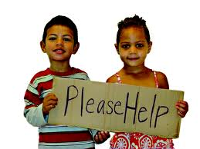We all have a lot to be thankful for, especially during this holiday season, so please take a few minutes out of your day and help those who need you! PATRICK PLACE APARTMENTS offers those who have little more than the clothes on their back, a place to call home. Offering 71 new apartments for people who are homeless and living in shelters, which will include on-site support services, and a roof garden!

For more info-
Beruke Giday, BerukeG@ccsww.org 206.450.9493
Samira Salkic,samira_salkic@keybank.com

601 N 34th St Ste A, Seattle WA 98103 (206) 545-2284

